Prehistoric tomb surveying (6)
The entrances of Dutch hunebedden

Dirk Kruithof, January 2019

In their study of hunebed orientation González-García and Costa-Ferrer included the orientation of the entrances also. A histogram of the entrance orientations displayed two peaks that mirrored around due south (azimuth 180º ± 15º). Although problematic, González-García and Costa-Ferrer associated the values with the rising and setting of a star with a declination of about -35º. Since the azimuth values agree with a bisection of a diagonal through two adjacent squares by due south more or less, maybe an explanation could be given in the context of the grid-of-squares geometry as described in PTS-1 . It was decided to have a systematic study of the entrances therefore. Since quite a few left entrance stones happen to have rather flat surfaces, they were chosen to be the subject of study.

The selection of entrance stones

Hunebed entrances are found midst the south-eastern chamber wall. Some entrances are extended by a portal of one or two trilithons. From a usage point of view, the entrance orientation could be quite important. The idea of an orientated entrance is emphasized by a lot of entrance stones that have flattened surfaces for both the chamber and entrance side. Often they stand in combination with other portal stone that have vaulted surfaces. Sometimes the placement of the other stones completely fails to support the idea of an entrance wall. Such setups seem to witness for some kind of intrinsic value of the flattened surfaces. The surfaces of a select group of left entrance stones were investigated on the possibility of a constructed orientation. The field work took place from autumn 2013 till the end of 2014.

A first selection was made via the comparison of earlier researches of tomb orientation .
Tombs were included when the reported orientations of the longitudinal axes didn't deviate more then 3º amongst the different studies. It was assumed that that the chamber sides of the entrance stones were related to the orientation of the longitudinal axis. Large deviations could

3 |  |  |  |  |  |  | D46 |  |  |  |  |  |  |  |  |  |  |  | D41
2 |  |  |  |  |  |  | D20 |  |  |  |  |  |  |  |  |  |  | D51 | D08
1 | D04 |  |  |  |  |  | D02 |  |  |  |  |  |  |  |  |  |  | D18 | D05 |  |  | D54 | D15 | D26 |  | D39 |  |  | D19
 | 0º | 1º | 2º | 3º | 4º | 5º | 6º | 7º | 8º | 9º | 10º | 11º | 12º | 13º | 14º | 15º | 16º | 17º | 18º | 19º | 20º | 21º | 22º | 23º | 24º | 25º | 26º | 27º | 28º
Orientation angle with due east or south
Figure 1
Histogram of the orientation of the longitudinal axes of some hunebedden, selected on the accuracy of the measurements (see text). The angles can be clockwise or anti-clockwise compared to due east or south. Yellow fields are to the north of east and blue fields are to the south of east. Green (D39) is to the west of south. Tomb D34 hasn't been rendered - it has an angle of 41½º to the east of south. The clear peaks come close to 6¾º from the bisection row of 53¼º and to 18½º from the row of 36¾º. Tomb D34 approximates 43º and near the half of it at 21½º there is a small cluster. Finally D39 approaches 26½º, again from the bisection row of 53¼º.
give problems then. This first selection was narrowed down by the demand that the left entrance stone should have well preserved flattened chamber and entrance sides and a traceable restoration history . Only the left entrance stones of D2, D4, D5, D15 and D20 remained. From these five stones it could be concluded that there existed no correlation between the longitudinal axis and chamber side of the left entrance stone. The chamber and the left entrance stone have an independent orientation. Therefore the criterion of less then 3º deviation amongst the studies was dropped and accordingly the selection was renewed. The final selection consisted of eight left entrance stones, that stand in situ and haven't been restored (D4, D17, D25, D30, D36, D37, D42, D43n) and six that have undergone a well documented restoration (D1, D2, D5, D15, D20, D43s).
N
S
W
E
Figure 2
Establishing the cardinal points in a horizontal plane by means of a laser leveller and four targets.
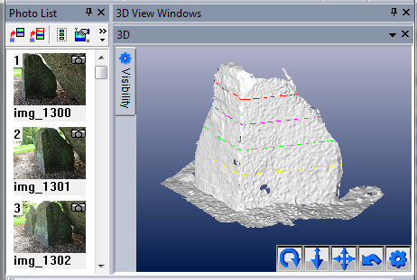
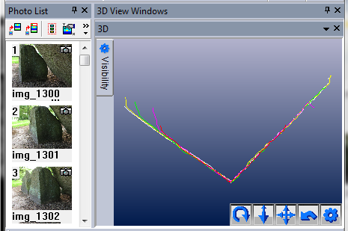
Building the 3D model
Figure 3
Screenshots of Photomodeler Scanner.
Top: Horizontal contour lines are created in a triangulated surface.
Bottom: Top view of the contour lines without displaying the surfaces.

Of all fourteen selected stones a 3D model was produced using photogrammetry. Before taking the photographs, the cardinal points were measured off in a horizontal plane and marked by special targets. Afterwards, the photos were processed in Photomodeler Scanner (the photogrammetry application) and a 3D model was produced. Five cross-sections at different levels in the 3D model (from top to ground) show the flatness of the surfaces. In a cross-section the accuracy of the angle between the chamber and entrance sides of a stone depends on the flatness purely and not on an instrumental fault. The correctness of a cross-section's orientation depends on the exact positioning of the targets for the cardinal points. The laser beams of the leveller had to be pointed at the central dots in the targets (± ¼º). For the six restored stones in the selection (except D15) and one non-restored stone (D42) the field model was used to produce an addition adjusted model. Both models are presented hereafter.

List of studied stones

A detailed description of the history of the left entrances stones follows now. First a status report is given according to Van Giffen (1927). Then the recent history (excavations, restorations and vandalism) is reported on. This is a compilation of the information by Bakker and Waterbolk (1980). Third the encountered status in the field is given. Finally it is described if, why and how the 3D field model is virtually restored.

The cross-sections of the stones are produced via photogrammetry. Within the 3D model five cross-section are displayed in a horizontal plane. Colours bottom-up are: white, yellow, green, purple and red. The distances between the cross-sections are spread equally and depend on the vertical size of the stones.

The left entrance stones that are in situ

D4-Z3'
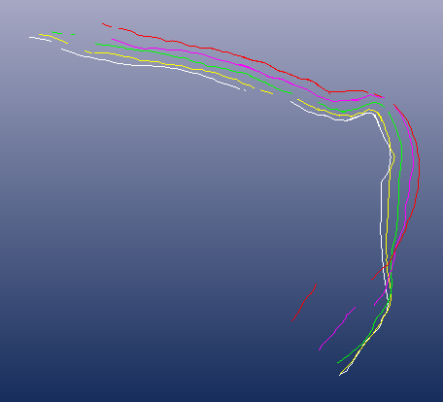
Van Giffen: In situ.
Recent: No restoration has taken place.
Status: Unchanged

D15-Z3'
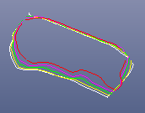
Van Giffen: More or less in situ.
Recent: The hunebed has been restored quite extensively in 1952. The stone was pushed inward a little.
Status: The stone stands according to the restoration in 1952.

D17-Z4'
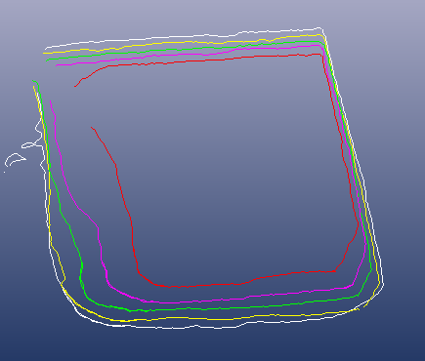
Van Giffen: In situ.
Recent: Probably the earliest report comes from 1547. A lot of diggings, small excavations and restorations have taken place.
Status: At the moment the stone leans a little outward and the capstone of the trilithon has slid off. This has affected the orientation probably, while the disturbances foil a substantiated virtual restoration. The stone is excluded from the selection.

D25-Z2'
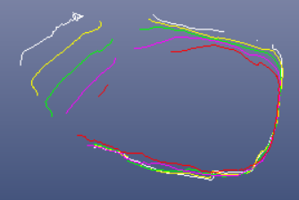
Van Giffen: More or less in situ.
Recent: Lukis and Dryden digged into the hunebed in 1878. A small restoration took place in 1960, but the orthostat stayed untouched probably.
Status: Unchanged.

D30-Z2'
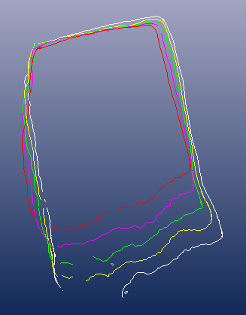
Van Giffen: More or less in situ.
Recent: Ongoing with the excavation of 1918 the hunebed has been restored. Details haven't been found.
Status: A photograph from 1918 shows the stone from top to toe. The current placement hasn't changed since then.

D36-Z3'
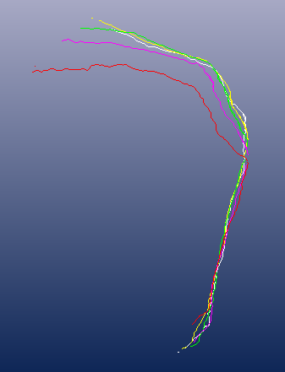
Van Giffen: Practically in situ.
Recent: In 1952 there has been a minor restoration and the stones haven't been touched. In 1960 Van Giffen thinks of a reorientation but this hasn't been actuated probably .
Status: Unchanged.

D37-Z4'
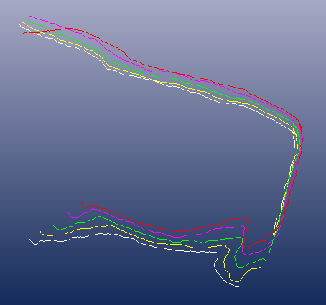
Van Giffen: Practically in situ.
Recent: In 1952 there has been a minor restoration and the stones haven't been touched. In 1960 Van Giffen thinks of a reorientation but this hasn't been actuated probably ⁶.
Status: Unchanged.

D43n-Z1'
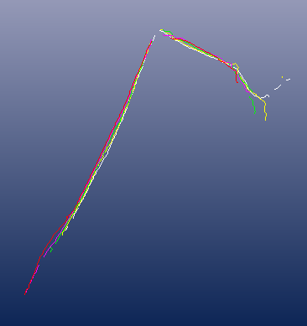
Van Giffen: Practically in situ.
Recent: Hunebed D43 has been excavated by Holwerda in 1913. In 1961 another excavation took place, this time concentrating upon the fencing mainly.
Status: Unchanged.

The left entrance stones that have been virtually restored

D1-Z3'
Van Giffen: At its original place.
Recent: In 1954 the hunebed got restored. The orthostat has been pushed inward a little to support the replaced capstone.
Status: Still the orthostat slopes outward a little.
Virtual restoration: The sides are restored to slope 80º and the stone is rotated -3º meanwhile. The southern chamber wall aligns at azimuth 77º (90º-13¼º, own measurement, bisection of a diagonal through two adjacent squares being 26½º). This
confirms to a placement of the entrance side at 193º (180º+13¼º). After the adjustment of the model, the entrance side has an orientation of azimuth 193º while the chamber side of the stone points due west. This is assumed to be the original situation.

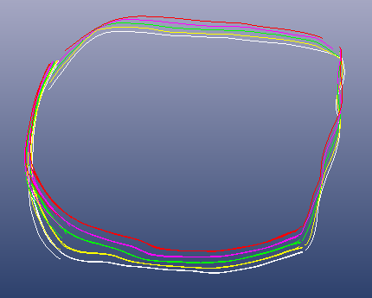 (field) 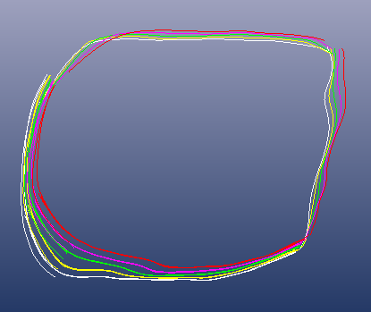 (virtually restored)

D2-Z2'
Van Giffen: Leaning inside.
Recent: With the restoration of 1952 the orthostat has been pushed outward.
Status: Now the stone slopes outward. Towards the top it distorts quite a lot.
Virtual restoration: The chamber side is adjusted to slope 80º.

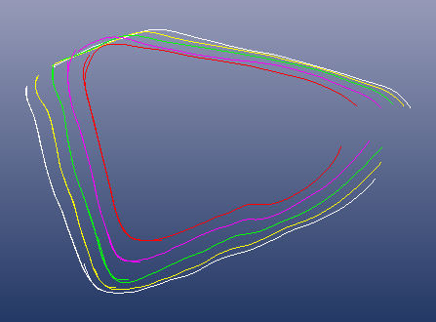 (field) 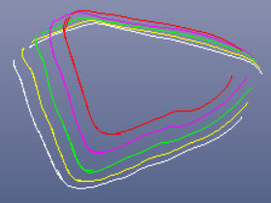 (virtually restored)

D5-Z2'
Van Giffen: Almost in situ.
Recent: During the restoration in 1962 the orientation of the stone has been adjusted a little.
Status: Maybe due to the restoration the entrance side of the stone slopes outward now.
Virtual restoration: The orientation is altered by +4º and the chamber and entrance side are placed vertical precisely. This way angle 18½º (the bisection of 36¾º, coming from a Pythagorean triangle) can be applied to the geometrical setup of the northern wall (90º + 18½º, own measurement), the entrance side (180º + 18½º), the chamber side (270º + 36¾º), and the angle between chamber and entrance side (90º + 18½º).

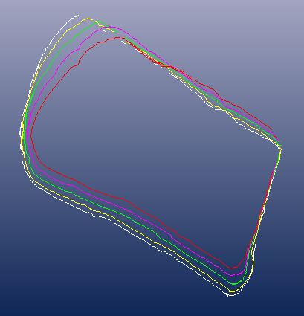 (field) 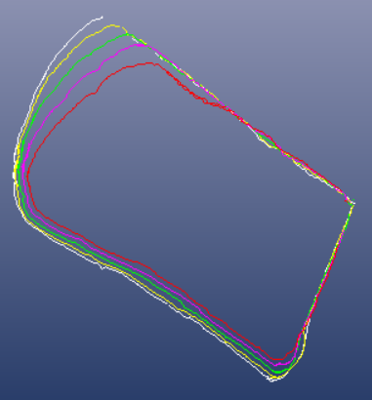 (virtually restored)

D20-Z3'
Van Giffen: Almost in situ.
Recent: Holwerda has excavated the tomb in 1912 and in 1961 a minor restoration took place.
Status: Maybe due to the excavation, the stone has rotated a little.
Virtual restoration: The stone has an extra entrance side. When a rotation of +2º is assumed during the excavation in 1912, turning the stone back will bring out ideal azimuth values (based on a constructing angle of 13¼º, see the next paragraph) for all three sides. The real entrance side will have an orientation of due south then.

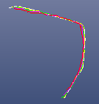 (field) 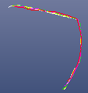 (virtually restored)

D42-Z5'
Van Giffen: In situ.
Recent: The hunebed has been restored in 1960, but the left entrance orthostat stayed untouched probably.
Status: The left entrance stone of D42 is sloping backward for the entrance side nowadays.
Virtual restoration: Adjusted to have the entrance side stand perpendicular exactly.

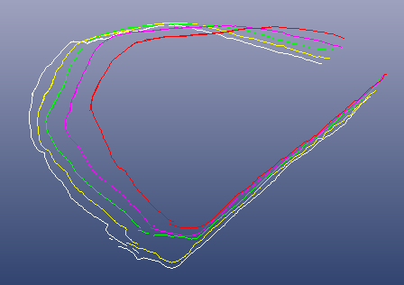 (field) 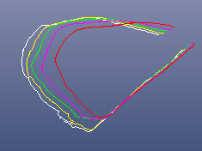 (virtually restored)

D43s-Z2'
Van Giffen: In situ.
Recent: The tomb has a sad restoration history. It starts in 1869, when the mound was dug away. The Dutch government acquired the hunebed in 1870 and according to Pleyte in short time some capstones had disappeared. In 1913 a first scientific excavation took place by Holwerda. He produced a realistic ground plan. The trilithon with the entrance stone seems to have subsided towards the entrance since then. In Van Giffen's atlas (1927) we can see the reason why. Here the capstone of the next trilithon is laid slantwise over the mentioned one. This was not the case in 1913. The trilithon of Z2' must have subsided by the weight of this capstone and by lack of buttress of the mound. Van Giffen restored the capstone again in 1960. In the ground plan of Holwerda the orthostat stands explicitly not aligned with the longitudinal orientation of the tomb. Nowadays it does.
Status: As said, the trilithon of Z2 and Z2' has subsided eastward and the capstone slants about 20º now. Z2 leans 25 cm too far inward. The capstone fits barely and thus both supporting orthostats must have undergone the same subsiding.
Virtual restoration: By virtually pushing the trilithon back so that its capstone gets levelled, Z2' will slope 10º more. Meanwhile the orientation of the chamber side adjusts to the situation on the ground plan of Holwerda. Moreover, the orientation of the chamber and entrance side become equal to that of the left entrance stone of twin tomb D43n, standing at a right angle.

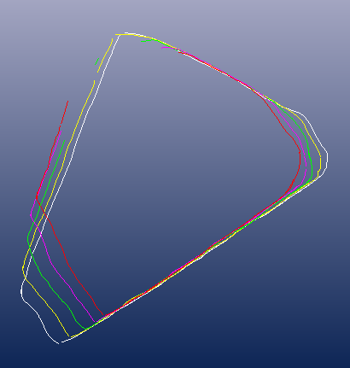 (field) 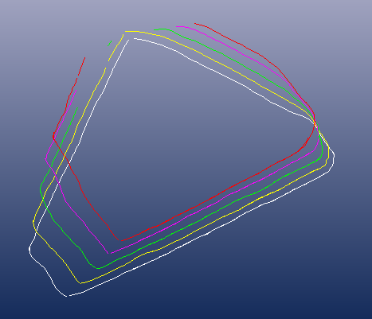 (virtually restored)

The processing and analysis of the data

All orientations and angles of the surfaces are measured in the cross-sections of the 3D model. If one of the cross-section clearly deviates from the others, it is disregarded as a local disturbance. Most of the time this counts for the cross-sections near the top. Therefore table 3 lists the average azimuths of the three lowest levels per stone. The maximum deviation from the average is written behind the azimuth values. Sometimes a disturbance shows up in all cross-sections, but none of these disturbances happen to cover the whole stone side. Still the azimuth of these surfaces can be taken then. In the end the photographs were decisive about the correct interpretation of the cross-sections.

The angle between the chamber and entrance side of an entrance stone happens to function as guide to the orientation of the stone. It is called the constructing angle (α) in table 3. All angles concerning the stone sides can be described in factors of the constructing angle. They can be used as the angle itself (α), its bisection (α÷2) or as a factor (α•2, a•3 or a•4). Three of those constructing angles showed up amongst the stones: as bisection of a diagonal through two or three adjacent squares (α = 13¼º or α = 9¼º) and as the bisection of the special angle 43º (α = 21½º). The constructing angle is used as an offset to the cardinal points, to longitudinal axis of the chamber or between the entrance and chamber side of the stone. All relations between chamber side, entrance side, cardinal points and the longitudinal axis should be described in order to get the left entrance stone successfully orientated.
13¼º
26½º
18½º
22½º
9¼º
43º
Figure 4
The constructing angles are produced via bisection of diagonals in a field of squares.
Left the diagonal and right the bisection.
D36-Z3'
D37-Z4'
Z
96¾º
96¾º
D43n-Z1'
D43s-Z2'
Z
O
D5-Z2'
Z
W
108½º
108½º
Figure 5
Graphical depiction of the ideal geometrical orientation of some left entrance stones.
Note that hunebedden D36 and D37 stand at a distance of about 15 meter. Their left entrance stones show the same orientation setup. The displayed angles (blue) are based on the constructing angles as 90º+α•2 (D5-Z2') and 90º+α÷2 (D36-Z3' and D37-Z4'), where α equals to the bisection of a diagonal through three and two adjacent squares respectively. Tombs D43n and D43s make part of a so called Langbett. If the proposed adjustment in the description of D43z-Z2' is correct, then their left entrance stones have identical orientations too.

The requirement of a complete orientation forms the basis of the rotation of the stones D1-Z3', D5-Z2' and D20-Z3'. Because of the multiple agreement with the constructing angle a virtual restoration becomes trustfully.

Three models are listed in table 3: a field model, a virtually restored model and a geometrical model. The field model represents the current situation in the field. The virtually restorations are discussed above and the geometrical model reflects the ideal values based on the constructing angles.

Reflection and conclusion

In the field model of the stones in situ the angles deviate 1.1º on average from the geometrical model and for the other stones 2.0º. After the virtual restoration of the latest stones the overall deviation amounts to 0.7º which is comparable to the deviation of the stones in situ. A similar picture emerges from the azimuth values of the chamber and entrance sides.

For the stones in situ the azimuth values in the field deviate no more then 0.6º on average from the geometrical expectation. Because some stones need a few degrees rotation in order to fit them to the geometrical setup, for the other stones the deviation of field values amounts to 2.3º on average. This is diminished to 0.9º after the rotation. On average the overall deviation between restored and geometrical setup amounts to 0.4º, which is comparable to the deviation of 0.6º of the non restored stones.

As a conclusion it occurs that the real angles in the field fit the ideal geometrical ones rather well. Taken together the average deviation of the angles and the azimuth values, it's warranted to allege that the involved left entrance stones have been orientated according to a few geometric principles. The bisection of a diagonal through two adjacent squares
(α = 13¼º) is used as the constructing angle for the setups of 11 out of 13 stones. Thereby it is by far the most preferred setup, which agrees with the overall picture in the other papers of the current study.

Table 1
The average deviation of angles and orientations of left entrance stones in table 3.

FieldAvg() gives the average deviation of the field models compared to the geometrical model.
RestAvg() gives the average deviation of the virtually restored stones compared to the geometrical model.

Orientations of the chamber sides:
FieldAvg( in situ ) = 0.6º FieldAvg( others ) = 2.6º FieldAvg( all ) = 1.5º
RestAvg( others ) = 0.3º RestAvg( all ) = 0.5º

Orientations of the entrance sides:
FieldAvg( in situ ) = 0.6º FieldAvg( others ) = 2.0º FieldAvg( all ) = 1.2º
RestAvg( others ) = 0.4º RestAvg( all ) = 0.5º

Angles between chamber and entrance sides:
FieldAvg( in situ ) = 1.1º FieldAvg( others ) = 2.0º FieldAvg( all ) = 1.3º
RestAvg( others ) = 0.3º RestAvg( all ) = 0.7º

Table 2
Angles of the flattened chamber and entrance sides and their deviation from the ideal geometrical values of
table 3. The first eight entrance stones stand in situ and haven't been virtually restored.

Entrance stone | D4  Z3' | D25  Z2' | D30  Z2' | D36  Z3' | D37  Z4' | D42  Z5' | D43n  Z1' | D1  Z3' | D2  Z2' | D5  Z2' | D15  Z3' | D20  Z3'a | D20  Z3'b | D43s  Z2'
Geometrical values | 103¼ | 96¾ | 90 | 96¾ | 96¾ | 53¼ | 90 | 76¾ | 36¾ | 108½ | 68½ | 103¼ | 76¾ | 90
Field  model | 102½ | 98 | 89½ | 98½ | 96 | 52 | 89½ | 78½ | 34½ | 110 | 68½ | 103½ | 75½ | 84
Deviation | ¾ | 1¼ | ½ | 1¾ | ¾ | 1¼ | ½ | 1¾ | 2¼ | 1½ | 0 | ¼ | 1¼ | 6
Virtual restoration |  |  |  |  |  |  |  | 76 | 35½ | 108 | 68½ | 103½ | 76½ | 90
Deviation |  |  |  |  |  |  |  | ¾ | 1¼ | ½ | 0 | ¼ | ¼ | 0

Table 1a
Left entrance stones that stand in situ. Orientations and angles per entrance stone.
When the azimuth of the longitudinal axis is placed between brackets, its value diverges over 3º amongst different studies.
'Diag. n:m' stands for the angle produced by a diagonal through a field of n×m squares.

Entrance stone | D4-Z3' | D25-Z2' | D30-Z2' | D36-Z3' | D37-Z4' | D42-Z5' | D43n-Z1'
Field model
Longitudinal axis | 270º | {273º} | {168º} | {285º} | {281º} | {308º} | {197º}
Chamber side | 283º ±0º | 284º ±0º | 167º ±1º | 291º ±0º | 290½º ±½º | 282º ±0º | 206½º ±½º
Entrance side | 180½º ±½º | 186º ±0º | 77½º ±½º | 192½º ±½º | 194½º ±½º | 230º ±0º | 117º ±0º
Angle between sides | 102½º | 98º | 89½º | 98½º | 96º | 52º | 89½º
Geometric model
Longitudinal axis | 270º | {---} | {166¾º} | {283¼º} | {283¼º} | {306¾º} | {198½º}
Chamber side | 283¼º | 283¼º | 166¾º | 290º | 290º | 283¼º | 206½º
Entrance side | 180º | 186¾º | 76¾º | 193¼º | 193¼º | 230º | 116½º
Angle between sides | 103¼º | 96½º | 100º | 96¾º | 96¾º | 53¼º | 90º
Constructing angle | α = 13¼º | α = 13¼º | α = 13¼º | α = 13¼º | α = 13¼º | α = 13¼º | α = 13¼º
Entrance vs. chamber side | 90º + α | 90º + α ÷ 2 | 90º | 90º + α ÷ 2 | 90º + α ÷ 2 | α • 4 | 90º
Chamber side vs. cardinal | α | α | α | α + α ÷ 2 | α + α ÷ 2 | α | α • 2
Entrances side vs. cardinal | 0º | α ÷ 2 | α | α | α | α • 3 | α • 2
Long. axis vs. chardinal | 0º | {---} | {α} | {α} | {α} | {diag. 3×4} | {diag. 1×3}
Long. axis vs. chamber side | α | {---} | {0º} | {α÷2} | {0º} | {---} | {---}

Table 1b
Left entrance stones that have been virtually restored (see the description per stone above). Orientations and angles per entrance stone.
When the azimuth of the longitudinal axis is placed between brackets, its value diverges over 3º amongst different studies.
'Diag. n:m' stands for the angle produced by a diagonal through a field of n×m squares.

Entrance stone | D1-Z3' | D2-Z2' | D5-Z2' | D15-Z3' | D20-Z3' | D43s-Z2'
Field model
Longitudinal axis | {263º} | 263½º | 288º | 292½º | 276½º | {197º}
Chamber side | 274º ±1º | 282º ±1º | 304º ±0º | 291½º ±½º | 285½º ±½º | 201º ±0º
Entrance side | 195½º ±½º | 247½º ±½º | 194º ±0º | 223º ±0º | 182º / 210º ±0º | 117º ±0º
Angle between sides | 78½º | 34½º | 110º | 68½º | 103½º / 75½º | 84º
Virtual restoration | Slope | Slope |  | Slope |  | Slope
 | Rotate -3¼º |  | Rotate +4º |  | Rotate -2º
Restored model
Longitudinal axis | {263º} | 263½º | 288º | 291½º | 276½º | {197º}
Chamber side | 270º ±0º | 282½º ±1½º | 307º ±0º | 291½º ±½º | 283½º ±½º | 206º ±0º
Entrance side | 194º ±1º | 247º ±0º | 199º ±0º | 223º ±0º | 180º / 207º ±0º | 116º ±0º
Angle between sides | 76º | 35½º | 108º | 68½º | 103½º / 76½º | 90º
Geometric model
Longitudinal axis | {263¼º} | 263¼º | 288½º | 291½º | 276¾ | {198½º}
Chamber side | 270º | 283¼º | 306¾º | 291½º | 283¼º | 206½º
Entrance side | 193¼º | 246½º | 198½º | 223º | 180º / 206½º | 116½º
Angle between sides | 76¼º | 36¾º | 108¼º | 68½º | 103¼º / 76¾º | 90º
Constructing angle | α = 13¼º | α = 13¼º | α = 9¼º | α = 21½º | α = 13¼º | α = 13¼º
Entrance vs. chamber side | 90º - α | atan(3:4) | 90º + α • 2 | 90º - α | 90º +/- α | 90º
Chamber side vs. cardinal | 0º | α | α • 4 | α | α | α • 2
Entrances side vs. cardinal | α | --- | α • 2 | α • 2 | 0º / α • 2 | α • 2
Long. axis vs. chardinal | {α ÷ 2} | α ÷ 2 | α • 2 | α | α ÷ 2 | {diag. 1×3}
Long. axis vs. chamber side | {α ÷ 2} | α + α ÷ 2 | α • 2 | 0º | α ÷ 2 | {---}

González-García and Costa-Ferrer 2003, pg.116
PTS stands for the title of the current study Prehistoric tomb surveying. The study is divided in several papers. Each of them covers another subject. Other papers are referred to as PTS-n, where n stands for the serial number.
The next researches have been consulted: Van Giffen 1925, Reijs 1997, González-García and Costa-Ferrer 2003 and Langbroek 2004
Van Giffen (1927), Bakker and Waterbolk (1980) and Bakker (1992). ⬇ Tomb no longer exists: D33, D48, G2, G3, G4. ⬇ Left entrance stone is missing or replaced: D9, D10, D12, D23, D26, D31, D34, D44, D45, D49, D51, D52, D53, G1, G5. ⬇ Van Giffen reported a serious disturbance: D2, D3, D7, D16, D29 and D54. ⬇ At least one side is not visible, curved, wrenched or decrepit: D3, D6, D8, D11, D13, D14, D19, D21, D22, D24, D27, D28, D29, D31, D32, D34, D35, D38, D39, D40, D41, D46, D47 and D51. ⬇ In the restoration report other supports are mentioned, but not the left entrance stone (indication that it wasn't touched): D7, D14, D15, D16, D35, D36, D37. ⬇ Van Giffen found the left entrance stone 'in situ' for: D1, D4, D6, D8, D11, D13, D17, D19, D21, D28, D34, D39, D40, D42, D50. In 1936 hunebed D50 got heavely damaged. ⬇ Van Giffen noted 'almost in situ': D5, D18, D20, D24, D25, D27, D30, D32, D38, D41, D43n, D46. Of those D24, D27, D32, D41 and D46 are deselected in one of the lists before. The restoration of D5 (1960) has been described in detail. In 1873 Gregory 'restored' hunebed D18 but left behind no documentation. From the excavation reports of D20, D25, D30 and D43n the impression arises that the left entrance orthostats stand in situ (resp. Holwerda 1912, Lukis and Dryden 1878, Van Giffen 1918 and Holwerda 1913 - see Bakker and Waterbolk (1980) p. 14, 37, 62 / Bakker (1992) p.161 / Van Giffen (1927)).
Numbering of the stones accoring to Van Giffen.
Bakker and Waterbolk 1980, p.37. In the report hunebedden D36 and D37 have been mixed up. The authors get their information from the Nieuwe Drentsche Volksalmanak of 1964 and deduced from the descriptions, the numbering of the hunebedden was exchanged in the article.
One might doubt if a side stone that slopes extraordinary already, should be pushed to slope even more. If this is regarded unacceptable, then the current capstone should be rejected as the original one for it barely fits between the side stones of the concerning trilithon. Considering the size of the capstone (± 1.6 meter) it may well have been a former side stone. It's very unlikely that it was dragged into its current place during the destructive activities in 1870, when the tomb was acquired by the state. There is no presumable place where it could have come from. According to the excavation of Holwerda in 1913 the ostensible gap between S1 and Z2 is filled by half a side stone (Van Giffen 1927, part 2, p.116/120). If this was the former place, then the exchange must have taken place in prehistoric times already. In that case the current situation must be regarded as 'intended' again.

